1. Participants log in using a unique ID and a shared Group ID. For example, participants could be assigned numbers 1, 2 and 3 but all have a group ID of 10.

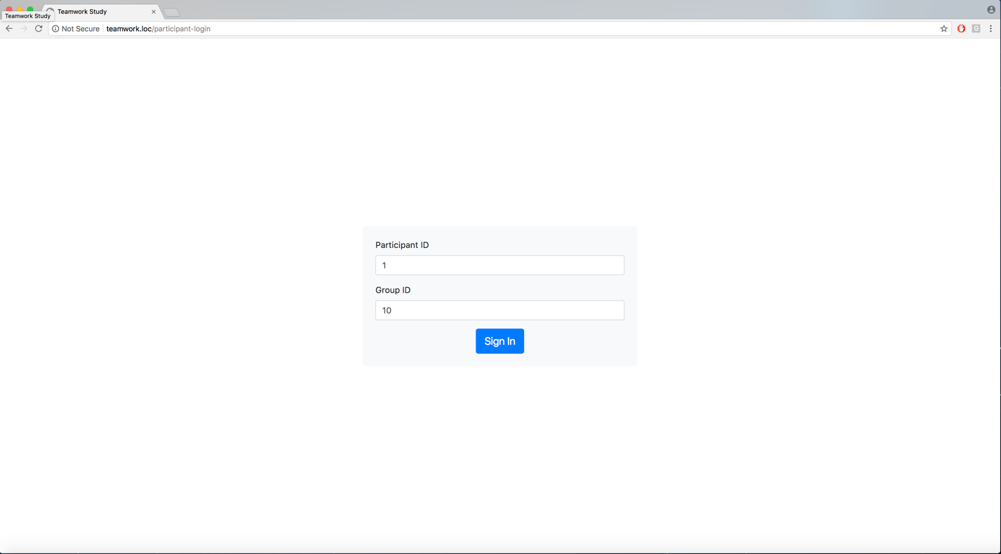

There are two tasks for the demo – the Unscramble Words task and the Brainstorming task. They are chosen randomly here, but there can be an option to have a set order if needed.

The Brainstorming task is an individual task. All individual tasks would follow this format.

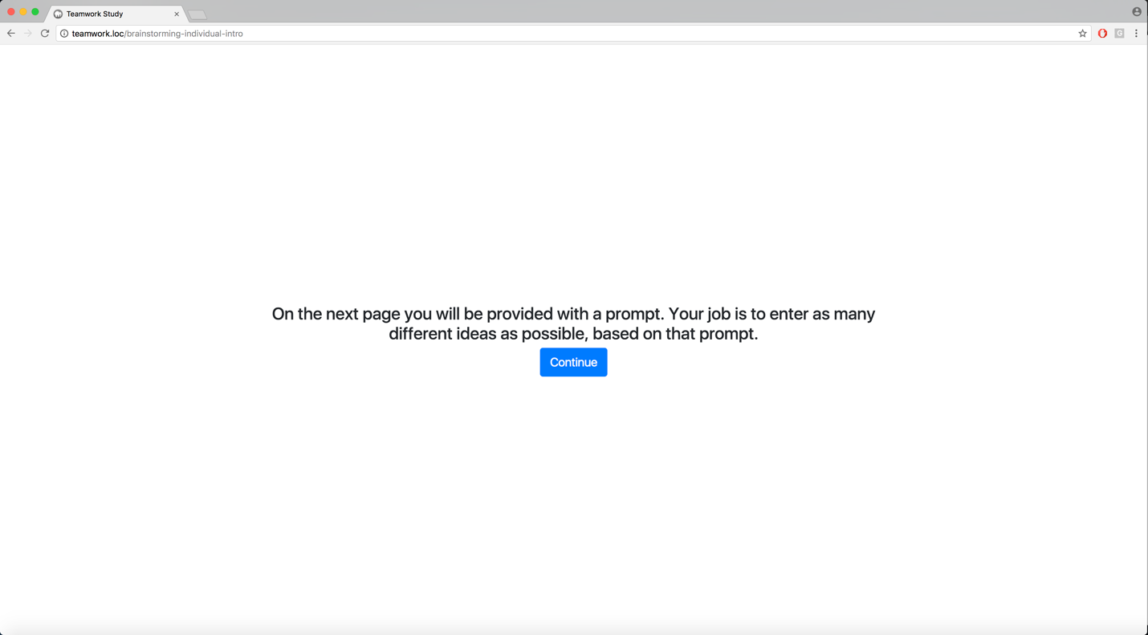

There are two prompts for the demo, all members of the same group receive the same prompt.

When the timer expires they are prompted to submit their answers.

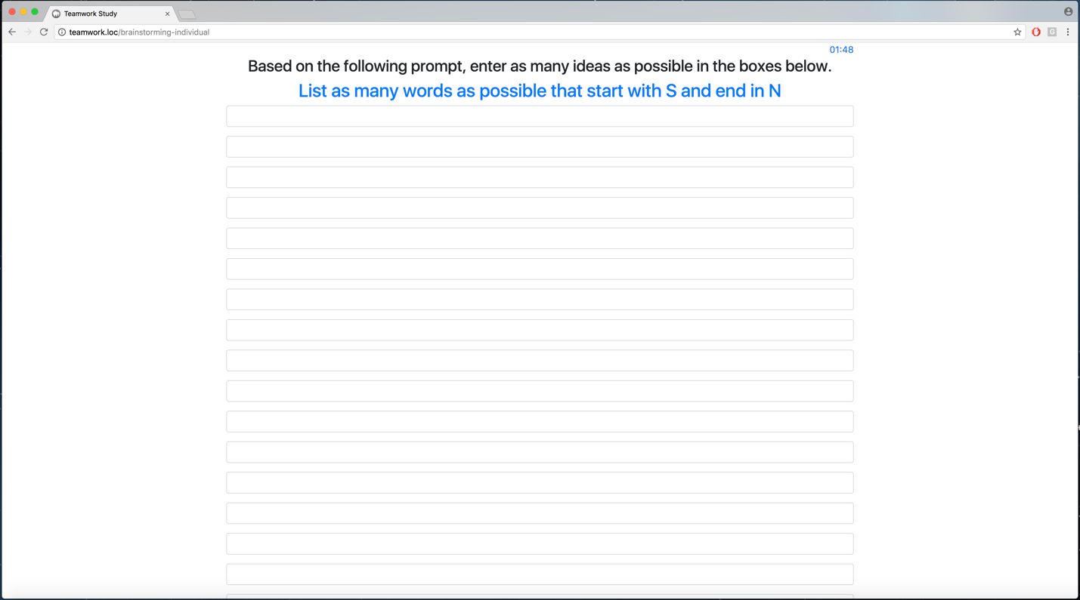

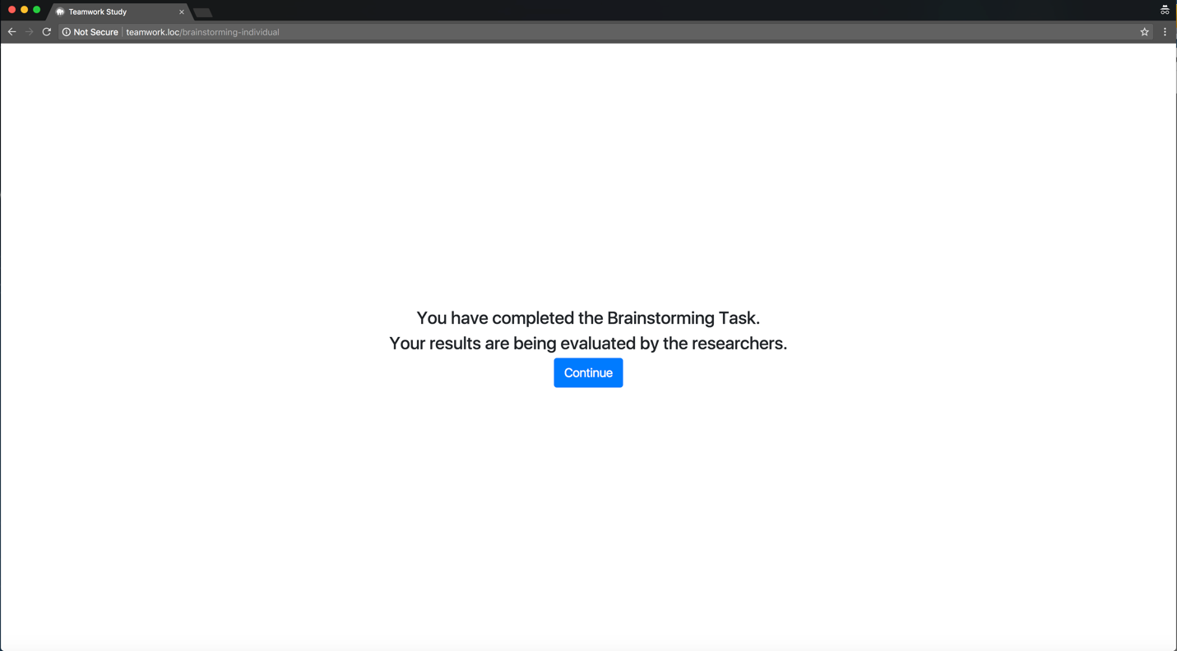

The other members of the group cannot move forward until everyone has completed the task.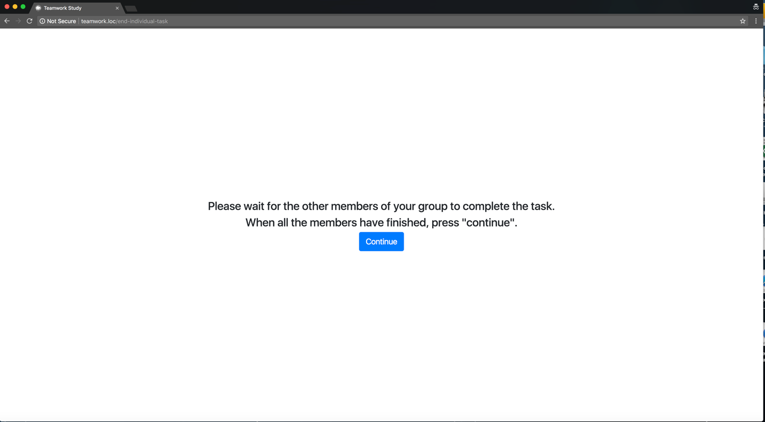

The individual responses can be presented all together if needed, or a new screen can be displayed where they enter a single group answer. At the end of the task, the group’s next task is presented.

This is a group task, so there is a prompt for one member of the group to sign in to enter the group’s answers. The other members of the group cannot continue past this point until the group answer is submitted.

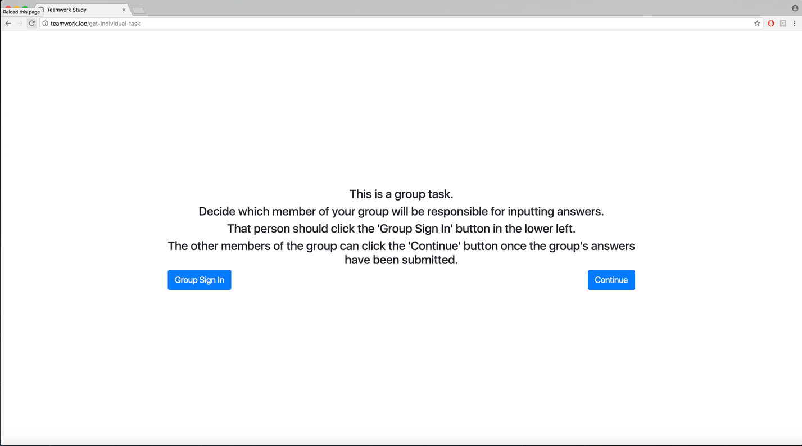

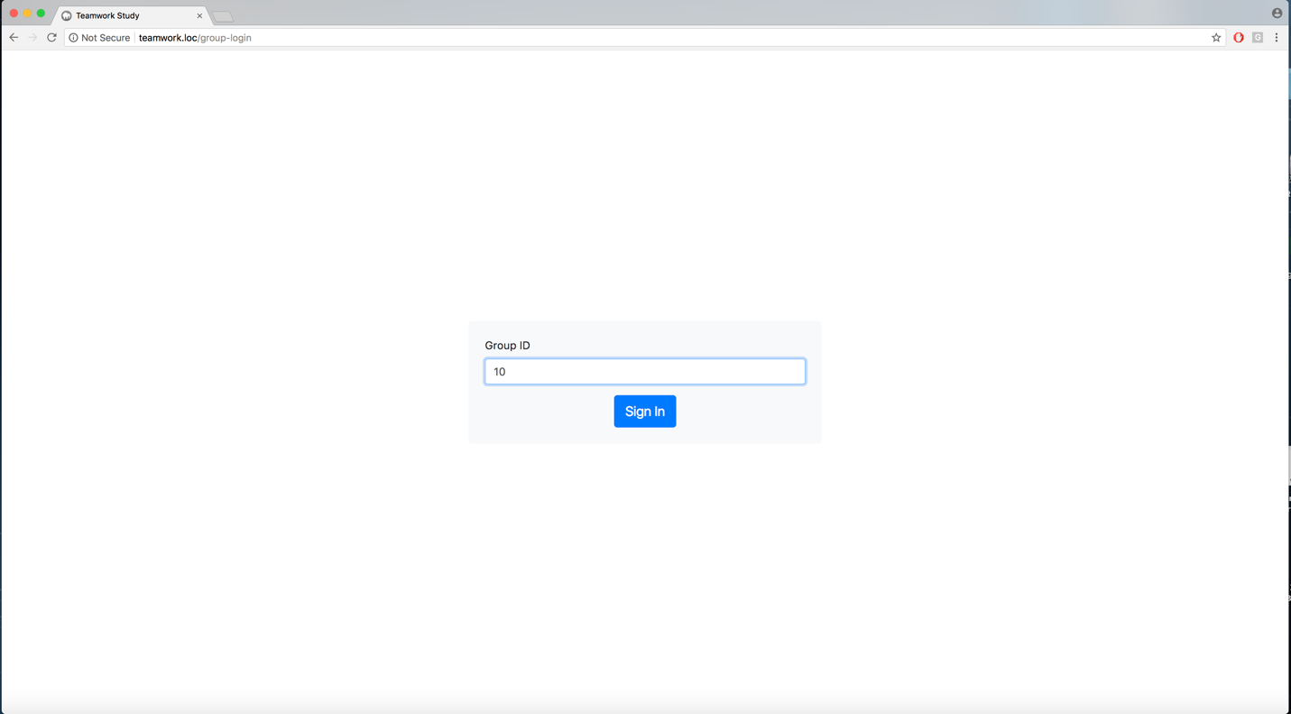

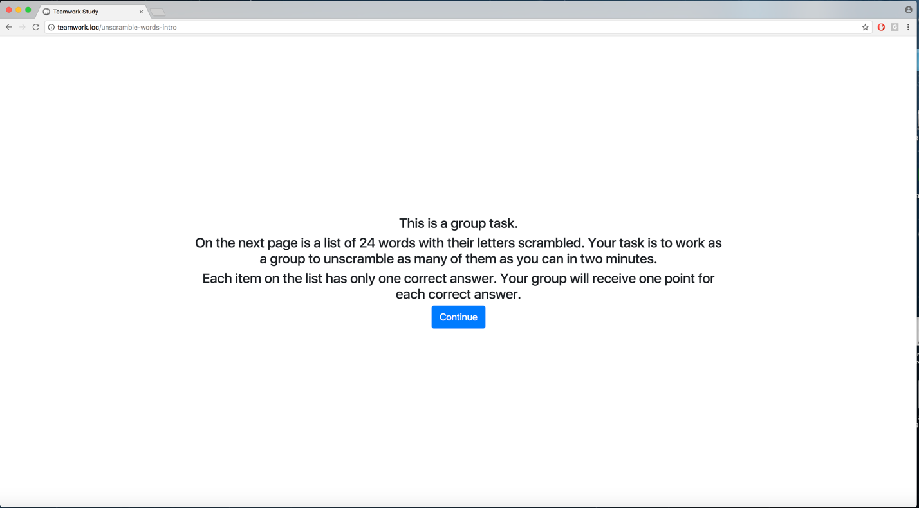

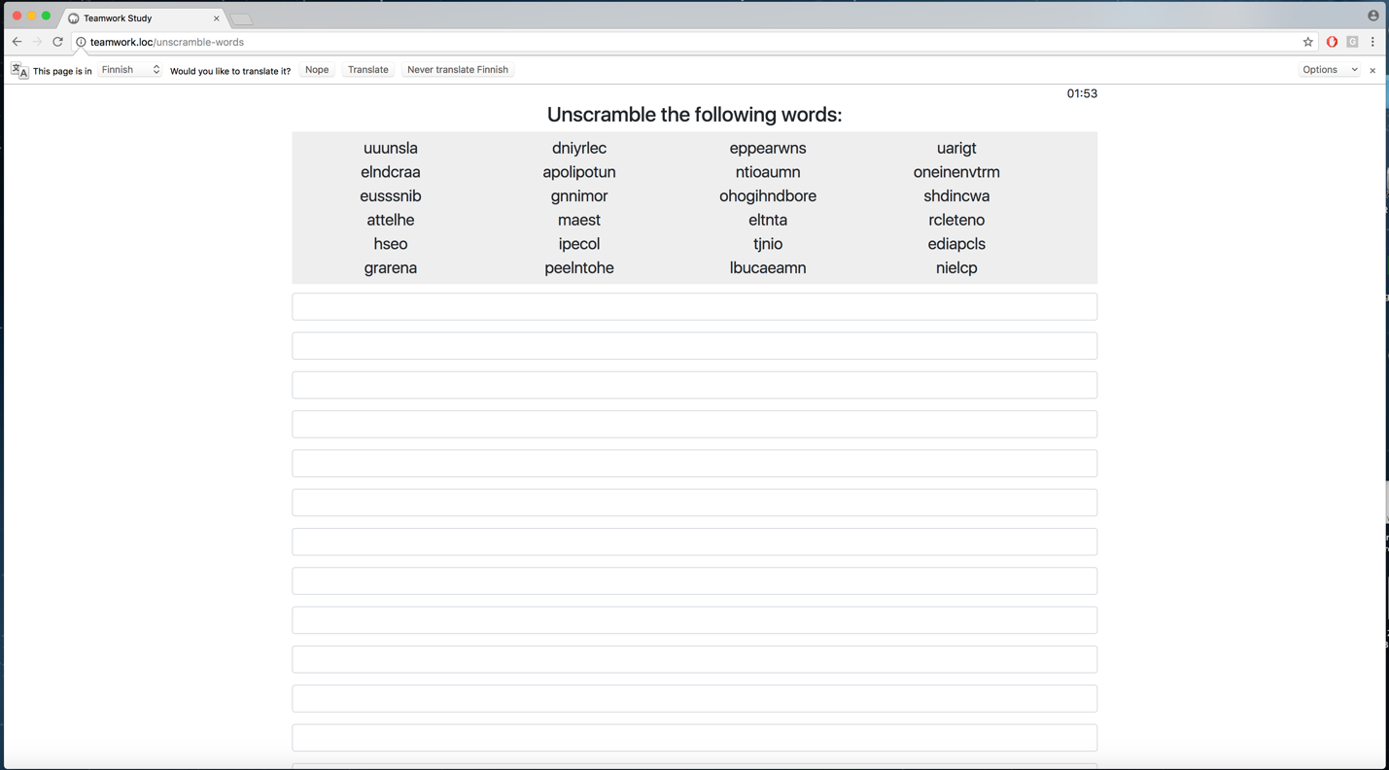

This task can be scored automatically.

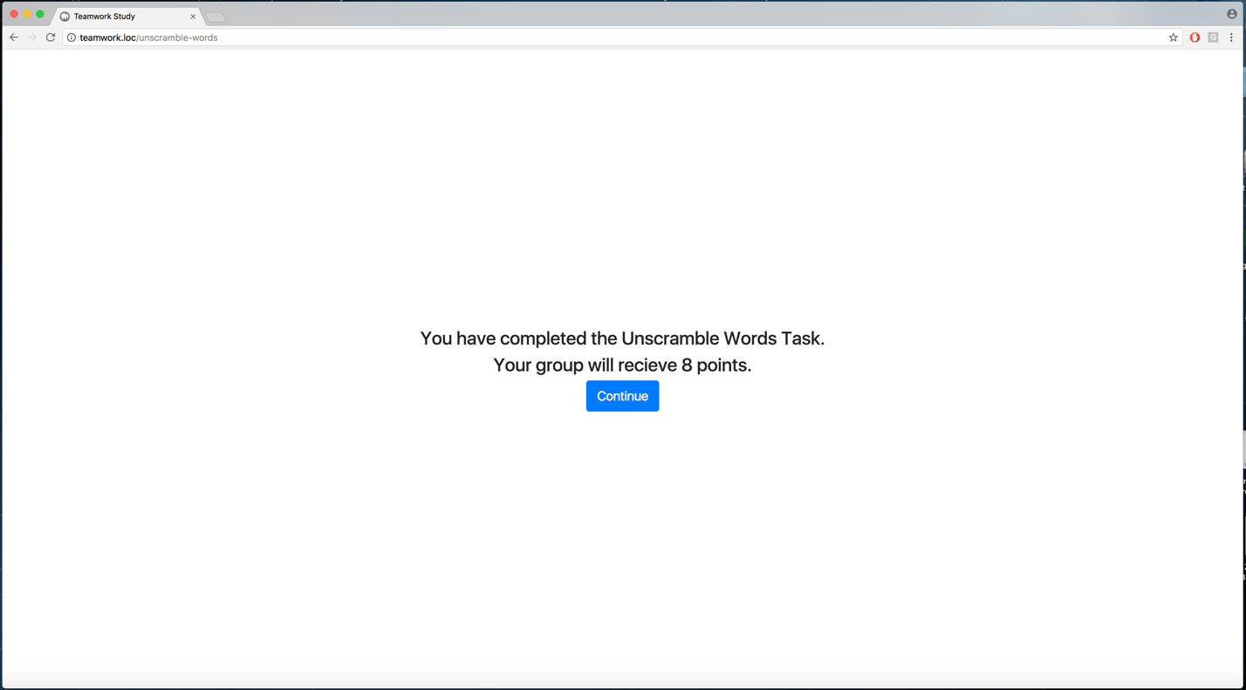

This takes us to the end of the demo.

